USER REQUIREMENTS

The Bidder should provide the following in the specified order in Section 4 of the proposal/bid document.

Provide detail information of the proposed solution as per document enclosed. Please note that marking should be carried out in the following manner; The Remarks column should be used to explain or provide detail information.

DESCRIPTION | REMARKS
Rating - 5 | If the User requirement is met 100% as defined in the RFP without any work around method.
Rating - 4 | If the User requirement is met 75% as defined in the RFP without any work around method. Define the number of hours required for the modification and cost in US$ in the Remarks column, in order to provide 100% functionality as defined.
Rating - 3 | If the User requirement is met 50% as defined in the RFP without any work around method. Define the number of hours required for the modification and cost in US$ in the Remarks column, in order to provide 100% functionality as defined.
Rating - 2 | If the User requirement is met 25% as defined in the RFP without any work around method. Define the number of hours required for the modification and cost in US$ in the Remarks column, in order to provide 100% functionality as defined.
Rating - 1 | If the User requirement is met as a Work around method defined in the RFP. Define the number of hours required for the modification and cost in US$ in the Remarks column, in order to provide 100% functionality as defined.
Rating - 0 | If the User requirement is not met as a defined in the RFP and modifications are required. Define the number of hours required for the modification and costs in US$ in the Remarks column.

The NBL rating is as follows:
1 = critical; 2 = essential; 3 = nice to have

FIXED DEPOSITS
Ref | User Requirements of Fixed Deposits | NBL Priority | Bidder’s Rating | Bidder’s Remarks
 | Facility to maintain basic customer information.  Maintenance of operating instructions | 1 | 4 | Supported by T24 through Customer Module. Some local enhancement may be required. This was discussed during the POC.
 | Lock as a under lien deposit | 1 | 5 | Handled by T24 Collateral module.
 | Facility to transfer of capital amount between permitted accounts & to generate a customer advice.  Facility to handle premature upliftments at different interest rates. | 1 | 5 | Supported by T24
 | Set interest payable instructions  Credit internal Bank A/c  Credit an A/c of different bank via slips / pay orders  Cash payments to be deposited to a suspense account. | 1 | 5 | Supported by T24
 | Set renewal instructions | 1 | 4 | Some local enhancement may be required.
 | Transfer interest to various customer accounts after deducting tax, if applicable. | 1 | 5 | Supported by T24
 | Maintain withholding tax recovered to obtain an advice and a statement at any particular date | 1 | 5 | Supported by T24
 | Identify the operative and inoperative status of the accounts. | 1 | 5 | Supported by T24
 | Transfer of dormant category and lock the accounts if the account is inoperative for a specified period. | 1 | 5 | T24 provide parameter table POSTING.RESTRICT to define specific transactions which prohibited for an account.  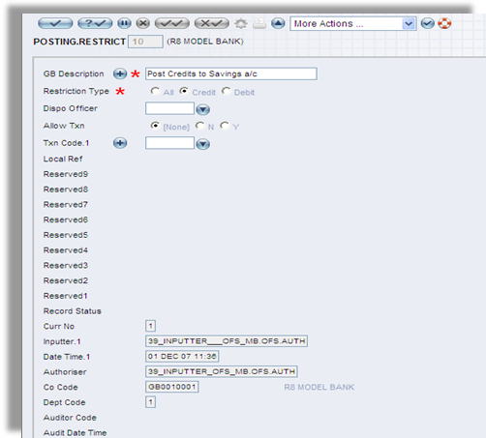  Figure 1. POSTING.RESTRICT
 | Identification of Currency type & revaluation of currency rates. | 1 | 5 | T24 is a multi-currency system by design and supports multiple currencies in terms of transactions, accounting. All currencies to be used are defined in the Currency table with currency code (usually according to ISO standard), number of decimal places, quotation rules, delivery days…  T24 supports multiple currencies and manage foreign currencies as well as local currency at all the business areas indicated. Transactions can be done for any defined currencies. An example of multi-currency facility is that a loan facility (limit) can be defined in one currency while the loan contract can be input in another currency and then drawdown can again be in a third currency, if necessary.  In addition, T24 supports multi-currency payments, disbursement and settlements. Payment/ settlement messages will be generated in the appropriate currency as specified in the transaction.  The revaluation in T24 is done on a daily basis during COB process.
 | Generation of report required by the Inland Revenue Dept. in their predefine formats. | 1 | 4 | T24 provides two powerful designer tools (Enquiry Designer and Report Designer) to enable Bank to define reports. In addition, T24 includes standard enquiry and report templates which Bank can use to construct its own report/enquiries in a relatively short time frame
 | Generation of Fixed Deposit Certificate in any currency. Fixed Deposit serial No. should be system generated. | 1 | 5 | Supported by T24
 | Facility to generate a maturity advice letter to customers | 1 | 5 | Supported by T24. Handled by T24 Delivery module.
 | Automatic renewal of maturated Fixed Deposits and provision to provide the interest rate as same. | 1 | 5 | Supported by T24
 | Facility to handle un-renewed and delayed claims with different interest calculations & relevant GL entry generation. | 1 | 5 | Handled by T24 Deposits functionality.
 | Facilitate cancellation of Fixed deposit certificate and to indicate the reason of cancellation at higher authorization. | 1 | 4 | Supported by T24
 | Generation of G/L entries automatically through the system. | 1 | 5 | This is Supported by T24. T24 generally provides for automatic accounting treatment based on the predefined rules. Accounting entries are generated automatically upon successful input of a transaction. Where transactions are inputted simultaneously, accounting entries are also generated in parallel for each simultaneous transaction.  Temenos T24 has built in functionality to ensure that the integrity of the accounting entries is maintained. In some instances where the accounting entries are accepted standards and any breach will go against the accepted principles of accounting, T24 ensures that the proper accounts are created automatically.
 | Partial amounts adding or Removing from the FD should be able to do easily |  | 5 | Handled by T24 Deposits functionality.
 | To facilitate Initial Deposit Pay in by cheque to Fixed Deposits |  | 5 | Handled by T24 Deposits functionality.
 | Facilitate on maturity of Fixed Deposits for any Interest Variance to be wiped out |  | 5 | Handled by T24 Deposits functionality.
 | Facilitate the Automated printing of Fixed Deposits on its maturity day after |  | 5 | Handled by T24 Deposits functionality and Delivery module.
 | To be able to print the advices as Original and Duplicate |  | 5 | Handled by T24 Deposits functionality.
 | Facility to incorporate a Penal Interest rate on premature upliftments and automatic calculation of withholding tax |  | 5 | Handled by T24 Deposits functionality.
 | FD  Trial Balance Full Report  Maturity/Interest/Capital |  | 5 | Supported by similar standard reports and enquiries.
 | Statement Printing should not capture same day reversals  Although it should be able to view via system  It should hold a First In and Out basis transaction order |  | 5 | Supported by Statement printing facility.
 | TC ISSUANCE |  | 5 | Supported by T24
 | For the purchase record to be printed together with the validation of the debit advice

